|  |
| --- |
| Radio for the Print Handicapped Co-operative Ltd |
| **Your voice on the radio** |
| A helpful guide on understanding how to best convey your voice over radio. |

**About this document**

Your voice is everything on radio. This short guide offers an overview of your voice and how to get the best from it for broadcast.

**What makes a great radio voice?**

* Warmth – Number 1 rule for 2RPH readers is to read as if you were speaking to a dear friend. This will convey warmth and friendliness in your voice. Better yet, put a smile on your face. This will change how you sound.
* Enunciate clearly – 2RPH is providing an information service for a wide range of people, including those who cannot read published material for themselves, so enunciation is key. No one wants to listen to mumbling or monotonous reading as this can make it different for the audience to clearly understand what is being articulated in the article.
* Be dynamic – Not in a sing-song way, but with real energy and effort. If you are bored or disengaged with the reading, the listeners will be too.
* Sincere - Think about the words you are saying. NEVER disconnect.

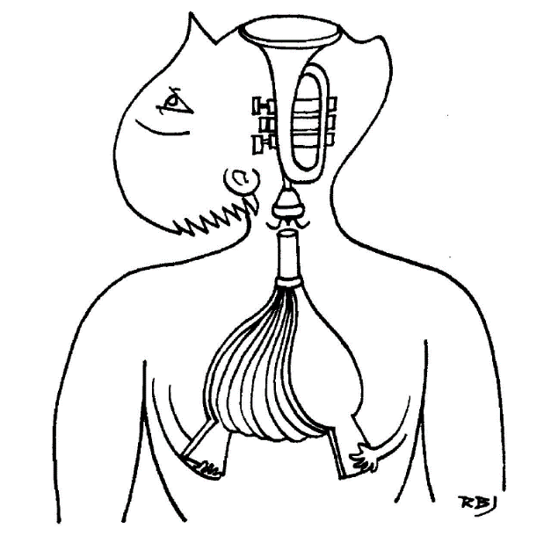

**Top tips from BBC broadcasters**

1. You don’t *have* a voice, you *use* a voice.
2. Warm up. The throat needs to be as relaxed as possible. You can’t beat humming and big breathing.
3. Don't bellow into the microphone. Think about just talking at the volume you’d use when talking to one person who is close by.
4. Breathe naturally - when you need to and through your mouth - to avoid sounding tense. 2RPH suggests taking 2 beats of breath after each sentence, and 3 beats after each paragraph. This gives you a chance to briefly scan ahead and to take a breath.

**How to… warm up your voice**

1. **Hydrate.** Drink warm water or tea with a slice of lemon when you get up in the morning and throughout the day. Don’t drink a lot of sugar or caffeine, which can have a drying effect on your voice. Avoid milk and dairy products, which encourage mucus production.

* Warm drinks are best, rather than very hot or cold drinks.
* Green apples contain pectin, which can combat phlegm. Try drinking green apple juice or eating a green apple.

**2. Relax your posture.** Relax your shoulders, but don’t stoop or slouch. Keep your body erect but relaxed. Good posture gives you the best use of your abdominal-diaphragmatic breathing. Slouching pressures the rib cage which makes it harder for you to inhale.

**3. Control your breathing.** Open a window, if possible, to make the air you’re breathing fresher. Breathe deeply into your lungs without raising your shoulders. Take breath into your nose for the count of three, pause, and then exhale in one big breath for a count of eight.

**4. Hum and buzz your lips.** To hum, exhale with a light “hmmmm” sound at a low octave that’s comfortable for you. Do this again, adding an “ahhh” sound for the second half of the exhale.

To buzz your lips, purse them somewhat and vibrate your lips as you breathe out, with your tongue relaxed. Inhale, then trill with your lips again on the exhale. You can try these exercises at escalating and deescalating pitches.

**5. Trill your tongue.** Hold your tongue behind your top teeth. Breath out, vibrating your tongue in the sound of an “r.”

Maintain the sound. Do this at various pitches, without going past your comfort level. This exercise helps your tongue to relax, while stimulating your voice and breath.

**How to… practice your radio voice**

Practicing is an important component to strengthen your radio voice.

**1. Exercise your vocal cords.** Choose words with specific sounds and repeat them going up and down the octaves of your vocal range. Repeat them again at a louder volume.

* Try repeating, “Mm-mmm. Mmm-hmm.”
* Try repeating, “Nay, nay, nay” ten times.
* Try making a siren sound using vowels up and down your vocal range.

**2. Enunciate your words.** Don’t mumble. Practice saying tongue-twisters at a rapid pace. Improve your speech quality and it will be easier for you to enunciate live at a faster pace.

* Try repeating, “Betty Botter bought a bit of butter” six times.
* Try repeating, “The ragged rascal ran around the ragged rocks” several times.

**3. Listen to your recorded voice.** Get to know the qualities of your voice. Evaluate how you handle mistakes and where you can make improvements. Make sure that you aren’t dwelling on your mistakes, which will just draw attention to them.

For example, if you mispronounce a word, just correct it – if that’s necessary for the audience to understand what you meant – and keep going.

**Get the most out of your voice – breathe**

Breathing gets you heard.

Unless you have been blessed with a naturally pleasing, clear, strong, melodic

and interesting voice, the following exercise are worth trying.

Breathing exercise:

1. Put one hand, with open fingers, on your upper stomach, the other on your lower rib cage.
2. Breathe in deeply, through your nose. Feel the air pushing your diaphragm and note where the pressure is against your hands.
3. Breathe out, slowly, through your mouth. Feel the pressure against your hands released.
4. Repeat this slow breathing - in through the nose and out through the mouth - three or four times, each time trying to get the air deeper into your lungs. Your lower hand should be pushed out before your upper one, and your shoulders should not rise or fall at any time.
5. When you feel you are filling your stomach up first, repeat the exercise up to 20 times.

This exercise will reveal how deeply you breathe. The aim is to get the air ‘down

into your stomach’ or, in reality, for your diaphragm to draw downwards so far

that your lungs are filled to proper capacity.

Repeat the exercise frequently until the new method of breathing becomes a habit. It will help control nerves but can also gradually change the noise you make when you speak.

**How to develop *interpretation***

Interpretation refers to how you interpret an article you are reading. *Where do you emphasise? Do you raise your voice at the end of a statement when it is not a question? Do you have colour in your voice rather than being monotonous?*

The following sections will showcase information and exercises on how to develop your ability to *interpret* an article.

**1.** **Resonance**

Mmm ah, Mmm ee, Mmm or, Mmm ay,

Ng ah, Ng oo**,** Ng ee Ng or, Ng ay

Moonbeam Nine men

Down and down One by one

No more room Down the lane

Leaning down Ring round the moon

Dream time Moonshine Love song

Time to go home One more time

Climbing down Sing me a tune

Where’ve you been? Who’s that man?

I’m rather bored When are they coming?

Wait a minute Where are you going?

**2. Varying your voice (Modulation)**

**Pitch**

High, medium and low produced by emotion or choosing a level for effect.

**Pace**

Should never be too fast for clarity.

**Pause**

All punctuation marks (written or thought).

**Power/Intensity**

Must be varied. All too loud will sound aggressive.

**Inflections**

Small glides up and down which give subtle meaning to the words.

Can produce sarcasm, irony and influence listeners to feel specific emotions.

**Tone colour**

The light and shade in the voice which gives sincerity. **Always think about** what

you are saying and the voice will sound natural.

**Practice:** Reply to an imaginary listener at the door who is enquiring for someone.

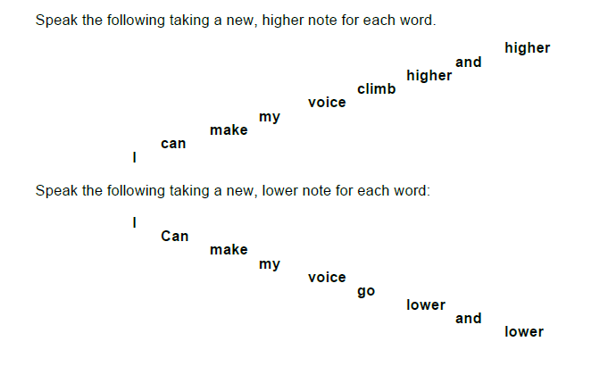

**3. Variety of pace, pitch, tone and stress**

Take each of the following key sentences and repeat them as many times as indicated: a., b, c, etc., to give the different meanings. (a, b, c, etc., will, of course, not be read). Try to get subtle compound inflection on the keyword.

**1. I thought you were going home today**

**a.** I wasn’t **sure**

b. **I** thought it was quite **settled**.

c. Not **tomorrow**

d. Not to your **office**

e. **I** certainly thought you were.

f. But that your **friend** was staying

(Had you a distinctive speech tune as well as a change of stress?)

**4. Emphasis (to point meaning)**

**1.**

A. Thelma has arrived

B. Thelma Green

A. Thelma White

B. Not the Thelma White?

A. Thelma White the writer

B. Thelma White the writer from Yorkshire?

A. Lancashire

B. I could have sworn it was Yorkshire

A. No, Lancashire

B. Oh yes, she was born in Yorkshire, then she went to live in Lancashire

A. Her father kept a grocer’s shop

B. Her mother kept the grocer’s shop

A. Then her father must have had the green grocer’s in Vicarage Road

B. The green grocer’s in Priory Walk

A. Let’s go and meet her

B. You can, I can’t stand the sight of her

Say the following phrases using the pitch of your voice to change the meaning:

1. It’s a scandal (secrecy, with hilarity, disgustedly)

2. Oh, to see the event first hand (dread, excitedly, mysteriously)

3. Just wait one moment. (with fear, with contained anger, happy)

**5. Tone quality (Giving meaning to words)**

Whenever the body reacts the vocal mechanism is also involved. That’s why, on the phone, you can hear nerves and whether someone is upset or happy.

Breathing patterns change, pitch shifts, the rhythm is different but most importantly, the vocal quality alters. When your throat gets tense because you’re angry, or relaxes because you’re bored, the rest of the world can hear.

The subtext is the actual message. **What you mean is much more important than what you say.**

How something is spoken, with a magical brew of:

Pitch

Tempo

Rhythm

Articulation

Pronunciation

Volume

Quality

Non-verbal noises are what carry the real meaning.

**Clarity - Speak precisely**

Plosive sounds PB TD KG. Open your mouth.

Saturday was a sad day to wake up to. Not only a sad day, but a bad day, for Kate Pringle, our good cook, for the third time planned to leave us – and before breakfast too – and we had to catch the train at Great Batterton at eight ten. This entailed eight dreary miles in the old Dodge.

Cook had downed tools on Friday at being asked to bake two fruit tarts of bottled black currants to follow the creamed cod and grilled chops. But my smart, pressed trousers and neatly tied tie made cook smile as with gloom graved deep on my brow, I took up the eight kippers for breakfast and prepared to cook them.

“You’re past praying for,” said Kate. “Cook kippers and all dressed up to kill?” So for the third time she stayed. We returned at night to find she had repented during the day and had planned a good meal of herb broth, roast pigeons, and rhubarb pie.

**Difficult combinations – make every sound in each word**

“The greatest story of past times” was the unanimous verdict of the critic’s circle when they were asked to *Arctic Snows,* the latest documentary to be revised this year. The strength of six-sixths of this starkest drama consists simply of the close-ups of the snow-covered clothes, the choicest shots, and the swiftness with which the climax is built up.

Fast-moving down to the last cue, with a series of swift strokes, the climax seems to burst before our astonished sight. The width and breadth of the conception is striking. Smith’s slick sixth scene is most moving when, past caring, he hacks through the snows with the strength of hardened steel to rescue his companions, who look like ghosts seen through the Arctic mists. The seventh scene of this breathless epic is past description. The snows cease, the mists clear, and as the party prepare for their last tasks, we see the screen flecked with choicest stars.

Twenty tiny tap dancers

Tapped to a bright light tune,

Their routine was smart and dainty

And they tapped and they did croon.

Tip tap tappety tap tap tip

Dippety dippety tap tap dip.

Teddy taught the tappers

To tap and flick their feet,

But it sometimes happened that the twenty

Tried too hard, and missed a beat,

So instead of

Tip tap tappety tap tap tip

Dippity, dippity, tap tap, dip,

It was

Tip tappety, tappety, tip

Dippity tappety dip tip dip.

**Watch out for problem sounds**

**NG** — do finish off every word ending in this sound.

A Frank, what are you doing?

B Drawing

A Not “King Kong conquers the Mongolians” again?

B No, some punk monks with their tongues sticking out.

A Will you be long?

**H**

This sound is made by breath — if you don’t take enough you won’t make it.

A Help!

B Who’s that? Harry? How are you? Who’re you howling at?

A You, Horace. hurry; I’m hung up.

B How horrible, Harry — does it hurt?

A My haversack harness is half-hitched to the hayloft hoist and I’m being hauled higher and higher.

B It looks quite hazardously hairy. Hang on and I’ll hasten for help.

***You are well on your way to fine-tuning your radio voice!***