Radio for the Print Handicapped Co-operative Ltd (2RPH)
How To Record in Studio
An overview of how to record a pre-recorded program in the 2RPH studios.

Introduction

This document covers what you’ll need to know for producing pre-recorded programs in the 2RPH studio. readings at 2RPH. The aim of 2RPH is to present radio content of consistently high quality, produced efficiently and professionally, and stored in an accessible way for distribution. 2RPH has limited studio availability, which must be shared by a growing number of people creating and producing programs.

The procedures in this document are to be followed once a program has been approved by the 2RPH Programming Advisory Group (PAG).
1. Timing of Programs
- Producers are responsible for ensuring the finished segment is within the prescribed timeframe. The final length of each segment produced must be no shorter nor longer than:
- 28 - 29 minutes for a half-hour slot
- 13.5 - 14 minutes for a 15-minute slot.

2. Booking a studio
- When organising to come into the station to record a book, you will first need to book one of the three studios on the premises
You can access the calendar of bookings for each studio here: https://www.2rph.org.au/mrbs/edit_users.php?datatable=1
- If you do not have your own login, please email Danielle on dhanrahan@2rph.org.au and she will email you login details.
- When booking a studio, please remember to put your Name and Contact Number in the box called, ‘Your name and contact number’. The reason this is important is so that if anyone needs to contact you regarding this booking, this can be done.
3. Creating your Intro, Mid and Outro
You will need to record an Intro, Mid and Outro for your program. For 15-minute programs, you will only need to record an Intro and Outro. These can be anywhere between 10-20 seconds.
- Intro example: Welcome to another episode of [insert program name]
[short summary of program].
Recorded for 2RPH - your radio reading service.
For example:
This is Ageing With Attitude. On 2RPH – your radio reading service.
Age is nothing. Attitude is everything. We explore articles on how older age can be a satisfying and emotionally healthy time of life. Living with joy, and understanding the inter-relationship of body, mind and spirit.
- Midtro example:
You’re listening to [program name], recorded for 2RPH - your radio reading service.
For example:
This is Ageing with Attitude, recorded in the studios of 2RPH – your radio reading service.
- Outro example: You have been listening to [program name], recorded for 2RPH - your radio reading service.
. You can hear new episodes of [program name] on [day] at [time] every [week/fortnight/month]. Visit 2rph.org.au to see when you can next hear [program name].
For example:
You have been listening to Ageing With Attitude, recorded in the studios of 2RPH in Sydney. You can hear new episodes of this program on Saturdays at 4pm every fortnight. Visit 2rph.org.au to see when you can next hear Ageing With Attitude.
- Develop a separate outro to request feedback on your program. Example script:
2RPH would love to get your feedback on our programming. You can do this by calling 2RPH on 02 9518 8811 or via our website www.2rph.org.au. Head to the Get Involved tab and click on Feedback.

You will need to record intro, midtro and outro stings separately from recording your program, and save them as individual files which you can drop into each episode of your program in the future. You can follow the steps in point 4 to do this.

If you require assistance with the choice of music, please consult the 2RPH Music Guidelines. You can also consult a 2RPH staff member for further clarification.
4. How to create a new file to start recording
- You will need to create a folder on ‘Record’ server which is named after your program (e.g. Ablequest, Animates etc). We can assist if you don’t know how to do this.
- On the computer, double click the Audition icon on the left-hand side. It should say Audition.
- Click on File in the top left-hand corner, then click New. A box will appear that states recording parameters. These should be: 44,100 samples per second, 16 bit and Mono. If it doesn’t say these parameters, please select them. Once done, click Okay.
- Before proceeding: Please “Save As” your file. Select File and Save As. A box should appear, which wants you to stipulate where you want to save this file. You want to save your recording in your new folder on the Record Server.
- Name each episode recording using the following convention: "YYMMDD PROGRAM NAME EP #.mp3". For example: "201101 Men's Matters #1.mp3"
- Files should be saved as .mp3.
- Switch to Multi-track view and Insert your with your Intro, Mid and Outro into Audition (drag and drop from the folder they are saved in.)
- Before starting to record, please do a setup test. When speaking into the microphone, record for a few seconds. You need to adjust your record volume (by using the Announcer fader) until the waveform takes up about half of the available area on screen. Please don’t touch the microphone itself but move it by touching the ring around the microphone.
- If using a CD, repeat this procedure by turning the Announcer microphone off and playing a few seconds of your CD and adjusting the CD fader for similar results.
5. How to record
For alternative methods of carrying out these procedures please refer to the Appendix.
- When you feel ready to start recording, press the red button on Audition’s control panel or press Control and the spacebar key at the same time on the keyboard.
- Don’t take notice of the levels on the desk, instead watch the levels on the computer screen.
- Remember to press the End key on the keyboard to automatically be taken to the end of your recording. This is to ensure you don’t overwrite what you have recorded.
- Always remember to Select File->Save as you work on your recording. Do not select Save As again as this will cause confusion and may result in corrupt data. Just select File->Save.
6. How to playback what you have recorded
- To listen to what you have recorded, press the blue button the control panel. You can then press the spacebar key on the keyboard to playback once the blue button has been pressed.

7. How to finish recording
- Once you have finished your recording, select File->Save.
- Once saved, you can either click on File and then, Exit. Or, click on the red x button on the top right-hand corner of the screen.
8. How to edit your recording
When you stop recording that section will be treated as your selection. As with any selected region it will be shown in reverse video.

- If you want to delete a specific part of your recording, zoom into its place in the recording by using the wheel on the mouse. Highlight the section you would like to delete and then press the Delete key on the keyboard.
- Also, pressing the Shift and left button on the mouse can highlight a specific section that you want to edit. Select the start of the part to select, hold down the left mouse button and drag to the end of your selection. Then release you mouse button before moving the mouse again.
- You have the following options:
1. Edit → Copy to copy the selection to the clipboard
2. Edit → Cut to remove the selection and move to the clipboard
3. Edit → Paste to either replace a selection with the clipboard contents or insert clipboard contents at a selected location.
- At completion of your session don’t forget to close Audition by File → Exit. If you have not saved your file prior to exit you will be warned to do so.

9. Saving, completing and storing
The production team relies on producers to keep their programs readily accessible for broadcast and podcast where applicable.

- When a program is assembled from several parts (e.g. interviews, article readings), create a folder for it within the program’s main folder in E: drive (record drive) and ensure all parts are saved in there.
- When the interview or recording is finished, save the original file, then copy it as a new file to use for editing.
- When you have completed the program ensure the the final version is available for retrieval by the production team per the exact file naming convention which identifies the broadcast date and the program: "YYMMDD PROGRAM NAME EP #.mp3". For example: "201101 Men's Matters #1.mp3"
- Optional information may be provided following the program name but is not essential. Example: 161013 Ablequest_Ep 432_Hansa Sailing_Chris Mitchell
- Save ONE file only (the final, ready for broadcast) with the correct file name, i.e. do not have two or more versions, as this makes it difficult for the production team to find the right file.
- When a program is only partially complete save it with the word "INCOMPLETE" appended to the filename. Remove the word "INCOMPLETE" when the file is ready for handover.

10. Programs that are also podcasted/available on demand via 2rph.org.au
There are a couple of extra steps to do if your program is podcasted or made available on demand via our website here. See here for examples: https://www.2rph.org.au/listen/podcasts

- Write a very brief description of the program for inclusion in the Audio Archives on 2RPH website; save it in Notes, in the same file naming convention as the audio file.
- Clean up your folders regularly and delete any unnecessary files to maximise space on the hard drive.
- Save the file in PCM wave (not ADPCM wav) format.
11. How to manage swearing/triggering content in articles
When reading content that includes profane language you must provide a warning in the intro to that article and where possible modify the content without altering the intent.
As a matter of practice, if you come across the occasional swear word you can read it fully or modify the content, e.g. the effing neighbour.
There may also be content that could illicit a strong or potentially harmful emotional response due to subject matter, coarse language or graphic descriptions of negative actions, violence or crime.
In either of these instances, the following content warning should be applied:
“2RPH advises that the following book contains....[BRIEF DESCRIPTION OF CONTENT] and listener discretion is advised.”
Depending on the content (particularly if it relates to suicide, domestic violence or mental health), we would recommend including the contact details of the following organisations:
Lifeline - 13 11 14 - lifeline.org.au
BeyondBlue - 1300 22 4636 – beyondblue.org.au
Suicide Call Back Service – 1300 659 467 – suicidecallbackservice.org.au
Butterfly Foundation National Helpline (help with eating disorders and body image) - 1800 334673
1800RESPECT (national sexual assault, domestic, family violence counselling) - 1800 737 732
More service can be found here: https://www.healthdirect.gov.au/mental-health-helplines
11. Completion deadlines
Reliability in producing content on time is critical to smooth operations at 2RPH.
- Complete a program at least (24-48 hours) prior to broadcast date/time.
- For weekends / Monday holidays, complete segments at least 48 hours prior.

12. Logging episode content
It is a requirement for all 2RPH Programmers to log the content they read out on their program. This enables to us keep track of what is being covered and assist in resolving any complaints that may arise or assist with any inquiries from our listeners.
In order to log your episode content:
- Head to the Pre Recorder Info Sheet here: https://docs.google.com/spreadsheets/d/10HbKrSpDzt8RY1a6j3Arwk2rrjPYyWSRqbMTDP_fdYg/edit#gid=479011418
- Find the row with your program name in the first left-hand column.
- Find the corresponding week column for that episode
- Briefly outline the articles, sources and subjects you covered in that episode.

12. Going on leave from your program
- If you are going on leave, submit one or two in advance.
- If on leave for an extended time, either ask someone to fill in for you or produce the program or record (and save using relevant dates) the requisite number of programs in advance.
13. Notify staff of complaints
Please notify 2RPH Content Manager or any 2RPH staff of any your book has been completed. This means that all episodes have been recorded, finalised with a intro, mid and outro theme and have been named appropriately.

14. Audacity – a A beginner’s guide.
AUDACITY is a free recording software program for use with PC’s and Macs (note: Audacity does not work with the latest Mac Catalina OS update).
If you’re new to this kind of software, Audacity is probably a good place to start.

(A) Download and install AUDACITY
Hovering the mouse pointer over the various buttons on the screen gives a description of what that button represents.
(B) The top left hand of screen has 6 buttons. They are (left to right):
Pause
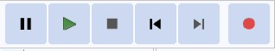
Play (green button)
Stop
Skip to start
Skip to end
Record (red button)

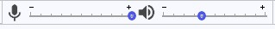
Look for the sliders to adjust recording volume and playback volume

- For Apple Mac users
Below in the centre are 4 pull-down tabs; hovering the mouse shows the settings:
Audio host - leave at default
Recording device - should default to current microphone plugged in
Recording channels - for 2RPH select mono channel
Playback device - defaults to current speakers/ headphones

- For Windows users
The same details appear as a panel and dropdown boxes, including the default microphone and speakers.
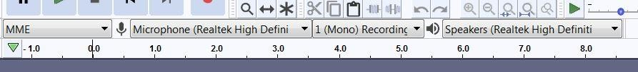

(C) Preparing to Record
Before you start recording, set the microphone level by clicking on the microphone icon or Start Monitoring,

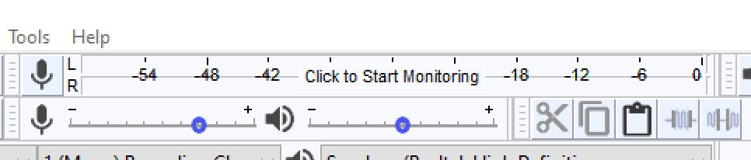
Then you can adjust the mic level with the slider below the level meter.
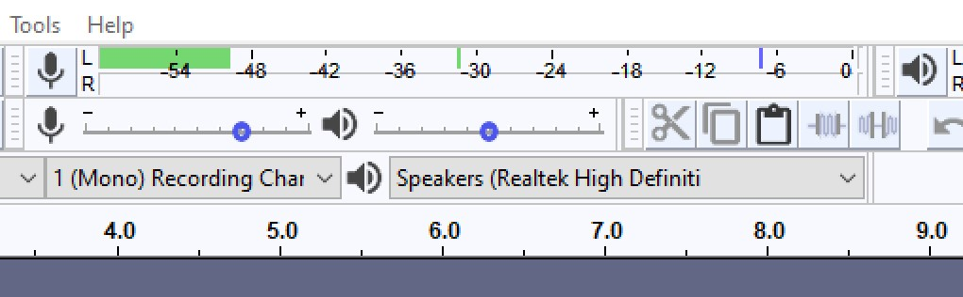

(D) Record

Press red button - a window will pop up showing the waveform of your voice.
To pause - click on the pause button. To resume, press pause button again
To finish - press the STOP button
To replay - press the play (green) button
Alternatively, pressing the space bar will play the recording from the start. Pressing the space bar again will stop the replay.

(E) SIMPLE EDIT
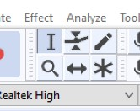
With the project open, you can easily edit out unwanted audio segments such as a cough or an error in reading.
First check that the selection tool is selected.
On the recording track left click and drag the mouse to select the piece you want to remove.
In the View menu you can select Zoom to expand the track making it a bit easier to see the selection.
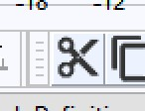
To remove the section of the recording you have highlighted, go to the Edit menu and select Delete or Cut, or press Ctrl + X on the key board, or click on the cut tool on the menu bar.
If you’re not happy with the edit, press Ctrl + Z to undo.

(F) IMPROVE AUDIO LEVEL
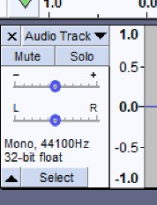
If the voice recording is a bit low you can fix that by selecting the voice track – press Select at the bottom of the box on left-hand side.
Then in the Effect menu select Normalise.
You would not do this if you had deliberately recorded audio with louder and softer parts.

(G) ADDING MUSIC OR OTHER AUDIO

These are the basics of adding music or other audio files to your voice recording.
You will need to have those audio files available on your computer in a suitable format – MP3 is best.
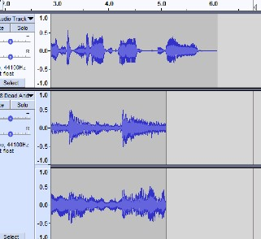
In the File Menu go to Import and then select Audio. Navigate to the file you want to add and double click. As a music file is in stereo, a new set of tracks will appear.
If needed, you can trim the music, as described in the basic edit section above.

If you now play the project, all tracks will play at the same time.

Separate the tracks by time shifting them. First select the time-shift tool. 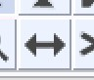

In this example, we want a brief music intro before the voice track begins.
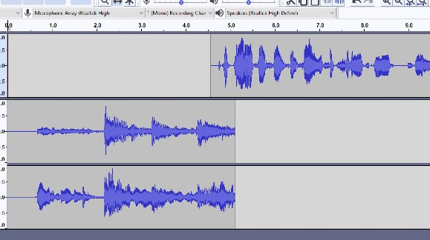
Select the voice track by pressing Select at the bottom of the box on left-hand side of the track (as in 7. above).

Then hold down the mouse whilst moving it down the time line, leaving a brief overlap with the end of the music tracks.

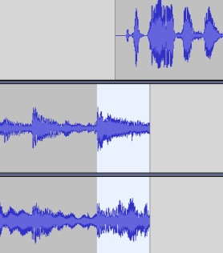
There are several ways to create a simple fade at the end of the music tracks. One method is to click the selection tool again, and select the section of the music tracks which overlap the voice track.

Then, under Effects Menu select Fade Out.

(H) Save a Project
In the File menu- select save as PROJECT and give it a name. Click on SAVE.
You can save the project where you wish.

(I) Save an MP3 file for 2RPH
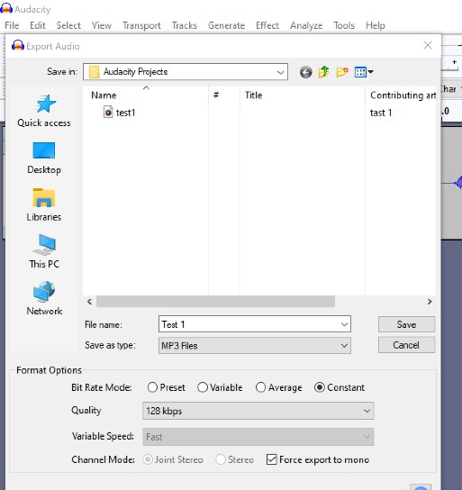
Go to File Export - select Export as MP3
Select the folder where you want the file to go
Give your MP3 a file name (see section 7 on file naming)
In Format Options:
Set the bit rate mode to Constant
Quality to 128kbps
Tick Force export to mono
Click on save

Note: There are many YouTube videos describing editing and more advanced features for Audacity.

15. Protocol for supplying copy and images.
If you are requested to provide, or would like to submit information about your program for inclusion in various 2RPH promotional outlets, the following protocols need to be followed:

Fact checking and quality. Please ensure that:

- The copy has been double checked for errors,
- The broadcast times and dates of your programs are correct and;
- The quality of your images are high-res.

What is hi-res?
Hi-res stands for high resolution image quality. Images are made of tiny pixels (picture elements), or squares of colour. You usually don’t notice individual pixels because they all blend together to form the picture that you recognize. You can see pixels when you zoom in to a picture, or if you try to enlarge an image beyond what it can handle.

The lo-res image looks only clear at its normal size (100%), but when we zoom in, it looks choppy. Enlarging lo-res images gives blurry results. This look is called “pixelated” because you can distinguish each pixel, in a block pattern. Hi-res is also easy to re-size.

Facial photographs
Photographs of faces to promote your program must meet the following criteria:

- It is a well know face that will attract attention;
- It is a beautiful photograph that will attract attention.

Example of a high-res image with a lot of pixels. The details are clean. the skin tones glow and it is in focus.

Example of a low-res image. It is out of focus, blurry and cannot be enlarged and is easy to overlook.
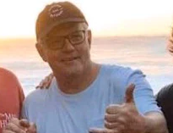

Example of a high-quality illustration. This is often more compelling than a bad photo.

16. Check list and tasks to be completed for new or revised programs
Here is a list of other tasks that you need to complete before your program goes to air. Please contact the Content Manager in regard to these: tkupara@2rph.org.au

- Provide an image for the 2RPH website Program Guide
- Provide a short descriptor for the website Program Guide (See our program guide for examples: https://www.2rph.org.au/program/sydney)
- Select some music for the program to be used as part of your intro, midtro and outro. (Please consult the Music Guidelines document for further information on this: https://www.2rph.org.au/2rph_admin/resources/2rph-music-guidelines.docx)
- Record a 30 – 50 sec promo for the program.
Here is an example script:
"Hello I'm Robert Snars. Join me for Mens’ Matters, a new program presenting articles on health, fitness, and mental and physical wellbeing from a male perspective.
From October 2020, Mens’ Matters will air fortnightly on Sunday evenings from 7:30pm, with a fortnightly repeated episode on Tuesdays from 3:30pm.
Head to 2RPH.org.au to see when you can next hear Mens’ Matters.
I look forward to your company."
- Consider a couple of ways or places that the program could be promoted (by the Administration Officer), in addition to the 2RPH website and social media.

Appendix
This section gives a comparison of menu items and keyboard shortcuts.

It is assumed that Audition is already open at this point. Those of you familiar with a word processor will be familiar with most of these shortcuts.

FUNCTION | MENU | KEYBOARD | NOTES
Create a workspace | File→ New | <CRTL>N | A horizontal green line will be seen in the main window.
Create a new file | File→ Save As | <CRTL><SHIFT>S | The file created will at this point be empty.
Save a file | File→ Save | <CRTL>S | Do this as often as you like to avoid loss of your hard work.
Go to the start of your recording | Left click at far left of recording | <HOME> | For the mouse method you must have zoomed out.
Go to the end of your recording | Left Click at far right of recording | <END> | As above.
Select a location | Left click at required location
Delete a selection | Edit→ Delete | <DEL>
Copy a selection | Edit→ Copy | <CRTL>C | Selection is copied to the clipboard.
Cut a selection | Edit→ Cut | <CRTL>X | Selection is moved to the clipboard.
Paste into work area | Edit→ Paste | <CRTL>V | If an area is already selected it will be replaced with the clipboard contents. Otherwise the clipboard contents will be placed at the current cursor position. Pasted material is highlighted as the selected area.
Undo last edit | Edit→ Undo | <CRTL>Z | There are about five levels of undo available.
Start recording | Left click on red dot in Auditions control panel | <CTRL><SPACEBAR>
Stop recording | <SPACEBAR>
Start playback | <SPACEBAR>
Stop playback | <SPACEBAR>
Close a file | File→ Close | <CRTL>W | Audition remains open as though it had just been restarted. If you have not saved your file since the last record or edit you will Be warned and allowed to either save the file or ignore it.
Quit | File→ Exit, left click on red cross at top right-hand corner of screen. | <ALT><f4> | A similar warning to that for Closing a file will be issued.

