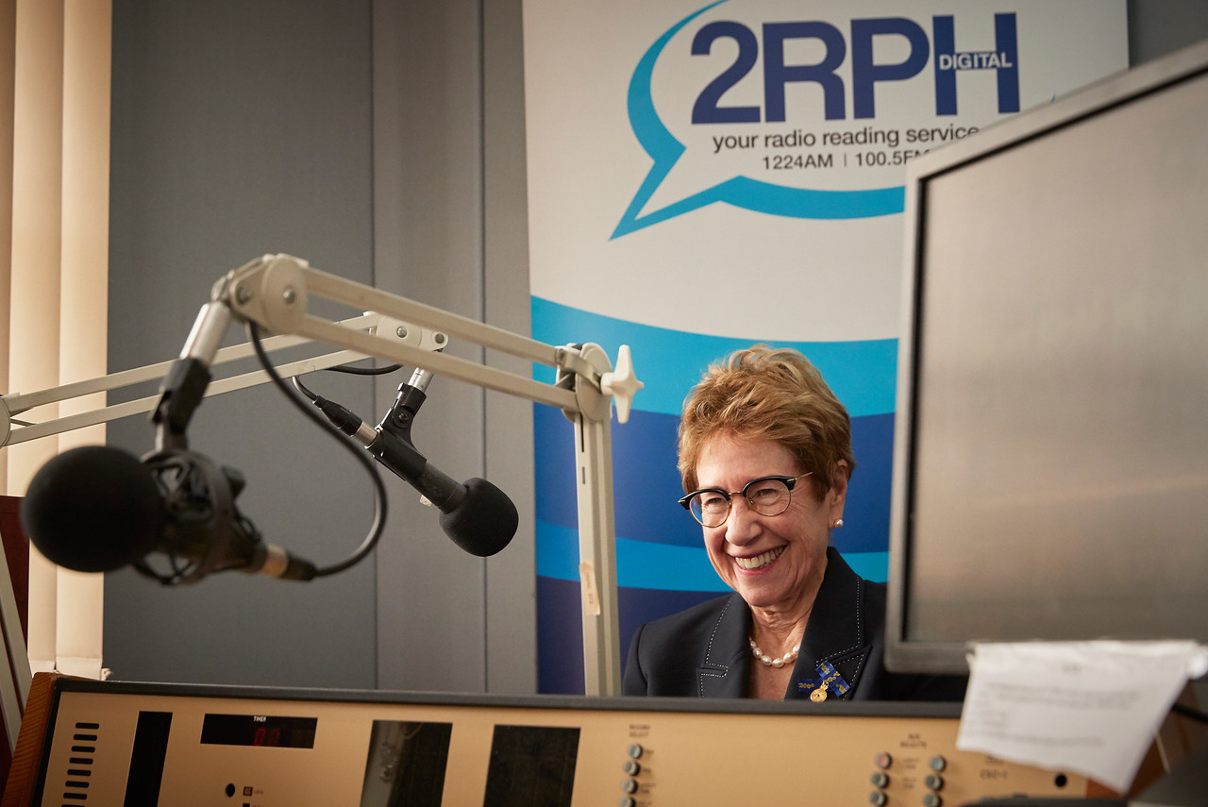
2RPH 2018-19
AGM: Report of the General Manager

Sancha Donald, General Manager
The past year has seen 2RPH continue to broadcast increasingly valuable and relevant content by highly skilled and trusted presenters
to our 100,000 listeners.

Listener response

To engage more directly with our listeners we participated, for the first time, in the Community Broadcasting Association of Australia’s (CBAA) Station Community Engagement Survey. It was extremely gratifying to learn that 89 per cent of the respondents rated the station as a trusted station and 93 per cent of respondents rated the content as valuable and relevant.

Areas for improvement such increasing the number of book readings and modernising the music content will be addressed over the next 12 months.

Program development

Our focus on refreshing our programs has resulted in launching six new programs including: Ageing with Attitude; Australian Police Journal; The Savvy Investor; Antiques Radio Show; ‘30 Laps with Dick’, and ‘Disability News’ as well as rebranding three programs to become Optimal Life (formerly Golden Generation); Considered Opinion(formerly Readers Write) and Sunday Papers, (formerly Sunday Telegraph and Sun Herald).

As part of strengthening links with the community, we initiated several programs that supported current events. We undertook a series of programs to highlight Australian team members taking part in the Invictus Games; and we celebrated International Day of People with Disability (IDWPD) by an interview with a woman, Fiona Wood who has an intellectual disability. Additionally, we produced, and now maintain, an audio version of the program to improve accessibility for those who are blind or who have low vision.
To support the growth in programs and the need for greater volunteer management we appointed Chris Yates, Program and Partnership Officer and Catherine Maitland, Volunteer and Community Engagement Officer.

Volunteers

To acknowledge our 200 volunteers, we have established two key volunteer functions per year. The Mid-Year Celebration saw the first group of volunteers, who have served the
station for 20 years, acknowledged by local member, Jamie Parker, MP while the Christmas function recognised volunteers under the ‘Generosity of Spirit Award’.

To create an environment in which our volunteers thrive we held the first of further Professional Development workshops, in partnership with the Community Media Training Organisation (CMTO).

The workshops form part of the overarching Professional Development Framework and received a satisfaction rating of 80% ‘good ‘or ‘excellent’ by attendees. Continual
improvement based on feedback now guides all subsequent workshops.

To ensure an excellent standard, and a diversity of reading voices, the audition process was refreshed and revitalised. The Audition Assessment committee, consisting of five volunteers, is now more formally constituted and reports to the Program and Advisory Group.

Profile building

To strengthen and extend our community of interest we entered into a partnership with
IDEAS, a key disability information service.
Central to the partnership is co-promotion of services and events across multiple platforms
to our separate audiences. This means 2RPH will be introduced to a further 400 members made up of people with disability, family members, carers and supporters of people with disability.

To reinforce other industry links, we attended the the Blind Citizens Australia (BCA) convention and the 2018 Community Broadcasting Association of Australia conference. The latter provided an opportunity to be part of the ‘Fostering your Station’s Accessibility for
People with a Disability’ panel session.

To broaden awareness of the station by the general public we:
- participated in the 2019 NSW Seniors Festival Expo as media partner to promote
the Expo and formed a partnership with the Department of Communities and Justice (formerly Department of Family and Community Services).
- We again partnered with the ABC to present the New Year’s Eve Fireworks program and extend coverage across Sydney, Newcastle, Hobart, Launceston, Devonport, Melbourne, regional Victoria and Adelaide.

The station’s profile received a significant boost amongst older Australians through:
- our involvement in the Premier’s Gala Concert program;
- an organisational profile in the Seniors’ Card newsletter; and
- an article in the LAND newspaper, giving a combined total audience of 500,000.
- Smaller promotional activities, such as supplying 2RPH collateral to
delegates attending the annual Stroke Recovery Conference were also carried out, to increase brand awareness.

2019/20 will see us sponsor the 2020 Sydney Festival ‘Access and Inclusion’ program which will provide recognition of 2RPH printed collateral and digital collateral (website, magazine, braille magazine edition, MP3 edition, newsletter, social media). Additionally, our 2019/20 plans will see 2RPH involved as a media supporter for the second Big Anxiety Festival.

Technology

Technical capacity is critical to being on air and hence is always at the forefront of our thinking. With a grant from the Lucy Guimelli Saini Trust we were able to upgrade the
Master Control Room. This now gives us the capability to broadcast from all three studios;
to remotely control equipment, and to reduce the number of manual broadcasting tasks.

Funding

As our financial future is fundamental to our ongoing work, we established an Endowment fund for legacy donations and launched a bequest program and brochure. Additionally, we secured three new ongoing sponsors (Seniors Rights Service, Communications Radio and Gospel Radio). Fundraising has also been assisted by improved website gateways and internal software.

We continue to be a member of the NSW Disability Advocacy Alliance and appreciate the efforts of the Alliance for its advocacy on behalf of members. The Alliance has been instrumental in securing further funding from the Department of Communities and Justice for an additional 12 months.

A special thanks to our core funding organisations: the Community Broadcasting Fund
(CBF); the Department of Community and Justice (DCJ); and the City of Sydney Council, whose support enables us to continue to develop 2RPH as a leading radio reading service.

Finally, I would like to thank the 2RPH staff for their work during the year, the 2RPH
Directors for their continued guidance, and our stakeholders, volunteers, listeners, sponsors and committees for their ongoing support.

Sancha Donald,
General Manager

