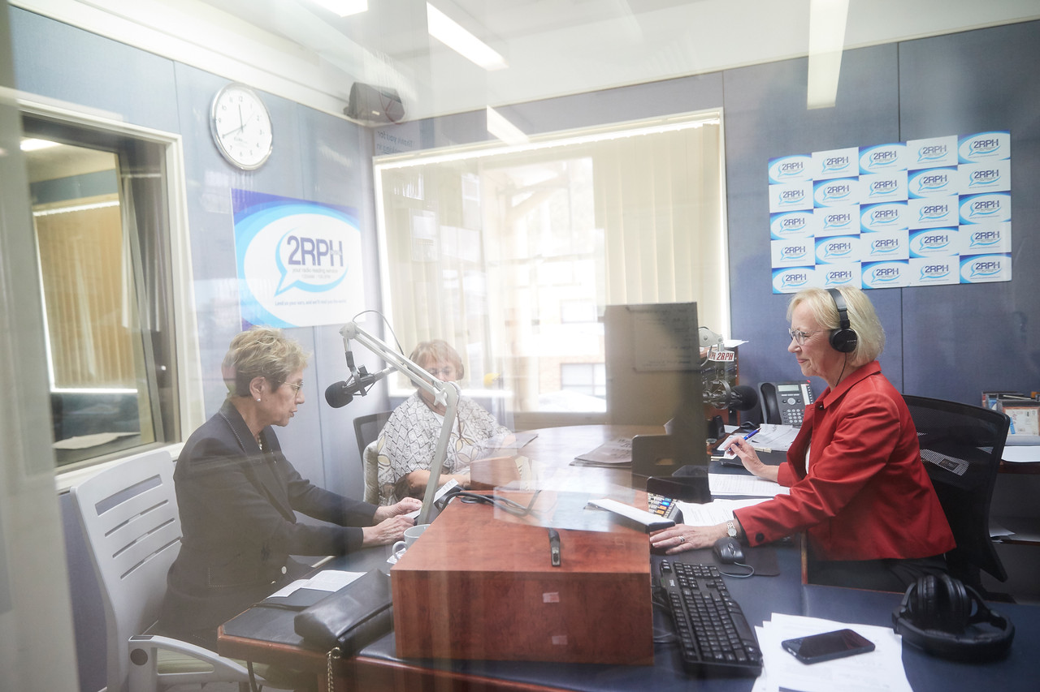
2RPH 2018-19
AGM: Report of the Chair

Di Collins, Chair
The Board

I want to commence this report by recognising and thanking those who have served on the Board over the past financial year. These people are Geoff Caban, Robert Estcourt, Maria Issaris, Brian Ollerton and Nick Bertram, the latter of whom stood down in January due to family and other commitments.

A Board decision to join the Community Broadcasting Association of Australia (CBAA), and to defer ongoing membership of RPHA, has led to more personal outreach with individual stations within our network. The need for a peak body which adequately and efficiently reflects the needs of the network remain. Consequently, the Board will continue to review what peak body arrangements might better help advocate for, and work in the best interests of, listeners and the network.

The Board has continued to work as a cohesive group and to carry out its governance and fiduciary responsibilities extremely effectively. The time commitment of those on the Board has been considerable and the legal responsibilities can be substantial, and I am particularly thankful for their support and dedication.

As part of seeking to strengthen the 2RPH Board we want to ensure greater continuity of decisions, programs, board membership, knowledge and administration by extending board appointments to three years rather than two. Additionally, to ensure the board is refreshed on a regular basis we are recommending limiting the length of overall service directors can serve on the Board to three terms of three years i.e. a total of nine years overall. These matters will be discussed and voted on at this AGM.

Strategy

Pivotal to the work we do is the listener. We exist purely to provide a service to those who, for any reason, are unable to access published material.

While our prime focus has been, and will continue to be, focused on people with a print disability, it has become clear there is a need for programs which will appeal more broadly to those with a wider range of needs.

Our role is to help keep listeners informed, entertained, enabled and engaged in the wider community. Hence our strategy needs to reflect this and to broaden our audience.
To date our strategy has successfully guided: new content; programs to recognise volunteers; resourcing to enable specialist staff to join 2RPH; continued growth in numbers of on-air readers and presenters; as well as endorsing outreach to key groups such as the Community Broadcasting Association of Australia; and Blind Citizens Australia.
The initial strategy has been for 2018-2020 and we are on track as we complete the second year of our three-year strategy. It is now timely to review that strategy and to commence planning for the next few years.

This review will take place over the next few months and will focus on how we will: captivate our audience; deliver sound governance and financial sustainability; and strengthen and extend our community of interest.

We will be seeking your involvement in this process to ensure that we reflect a wide range of opinion and need. We will also seek your involvement in addressing the concern that the inclusion of the word ‘handicapped’ in our name causes in the wider community.

Our overall strategy will involve utilising available technology to provide a range of listening options. Whether that be by streaming, podcasts, or on demand, we will be looking to ensure as high a transmission quality as possible.

I mentioned in my last report that Broadcast Australia was in ongoing discussions with the 2RPH Board regarding 2RPH switching fully to the FM band. Since then there have been no further communications, or proposals, from Broadcast Australia about this. We understand that this is due to organisational restructuring at Broadcast Australia and to a change in personnel and their responsibilities.

Financial

Importantly the year has finished on a strong financial note, the details of which have been provided separately and which we are scheduled to discuss in detail at the AGM. However, these results come with a strong note of caution. While we have had a successful year, we cannot expect these results to continue or to be sufficient to ensure ongoing replacement of the funding that we lose under current arrangements with the Department of Community and Justice, formerly known as Family and Community Services.

2020

By way of summary, 2020 will see the Board guiding efforts and discussions on: the 2020-2025 strategy; fund-raising and business development programs; and reviewing the name and rebranding of the station.

In particular, we will continue to strengthen the 2RPH Board and to seek a qualified person with a disability to join the Board. Separately, we have sought to strengthen the Board by filling two casual vacancies notably with John Martin and Geraldine Menere.

John is a stalwart of the community broadcasting sector having served on the boards of the Community Broadcasting Foundation (CBF) and that of the Community Broadcasting Association of Australia (CBAA). Geraldine (Gerry) is a Senior Lawyer with Justice Connect working with Local Aboriginal Land Councils. As such, she has a wealth of governance experience to help guide 2RPH and contribute to our efforts.

Thank you

I want to thank all those volunteers, sponsors, funding bodies and donors who have contributed their time and, or money, to 2RPH over the past year. The involvement of volunteers on committees, notably the Program Advisory Group, the Service Delivery Committee, the Engagement Committee and the Audition Committee have made a real difference.

Importantly thanks are due to those volunteers at the station who read and who assist where needed. These efforts have been intrinsic to the success that 2RPH has achieved.

Under the guidance of General Manager, Sancha Donald, and her team of Peter Worthington, Danielle Hanrahan and Catherine Maitland, we have been successful in promoting the organisation to a wider audience; improving and expanding programming; and maintaining an ongoing commitment to training and recognising volunteers.

As part of recognising long-term volunteers we are seeking your endorsement, and change to the 2RPH Constitution, to admit those who have consistently volunteered over 25 years with 2RPH by being honoured with Life Membership.

On behalf of the Board, I want to thank all for your work, commitment and dedication to 2RPH. The Board, and I, are looking forward to your continued support and involvement in 2020.

Thank you again for your efforts.

Di Collins,
Chair

