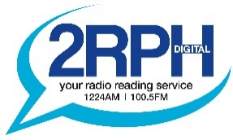
2RPH Program Review Assessment Criteria

Each submission will be carefully reviewed by one of the 12 members of the 2RPH Program Review Committee. Once the initial assessment has been made, following a review against the below assessment criteria, final assessment will be made by the Program Advisory Committee.

Guided by your comments in the submission/proposal form, your submission will be assessed based on the following six criteria:

Program topic/focus: You are asked to select a category that best describes the program. While this will provide a general idea of the subject matter, the program will be assessed on its focus within the selected category. The assessment will consider: clarity of focus and whether it aligns with 2RPH’s values and community of interest.

Format/elements: The program will be assessed on its format. Whether it is a selection of articles to be read or interviews with listeners/experts in the field, or is a mix of elements and how your approach might be sustained. As part of its program review, 2RPH is focused on developing diversity in program format.

Program values: As part of its commitment to deliver a radio reading service that seeks to remain relevant to its current listeners, as well as its ‘community of interest’, 2RPH aims to develop programs that meet the following values: educational, entertaining, current/relevant, and unique.

Definition of ‘community of interest’: Radio 2RPH aims to inform, educate and entertain New South Wales’ listeners who primarily comprise: those with print disabilities, those who lack access to published material, or those whose lifestyles limit time for reading and remaining informed.

Source of material: The program will be assessed on the requirements for putting it together, such as availability of resources.

Experience of producer: Putting a program together requires knowledge and prior experience to not only read confidently on-air but in managing the technical components of recording a program, managing your interviews with callers, saving recorded programs and using the studio equipment.

A total out of a maximum of 25 marks will be given to each program submission.

